I am pleased to inform you that my work will be exhibited by Lahd Gallery at ART16 London from the 19th to the 22nd of May
El Ultimo Suspiro del Moro. Patrick Altes

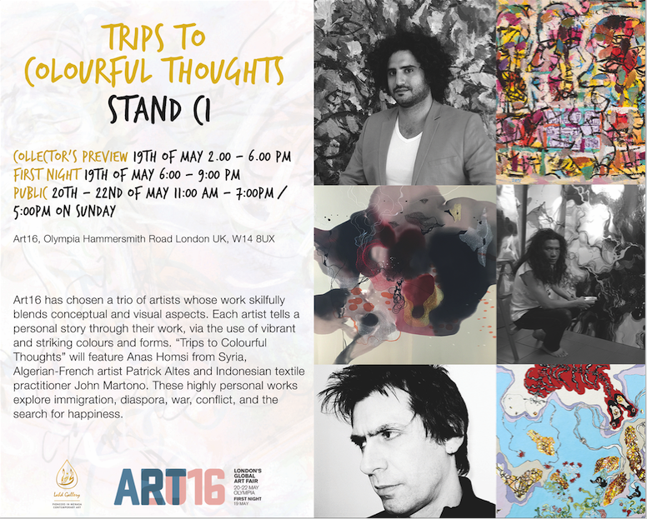

Visitors to London’s Art16 Fair this May will be treated to a boldly coloured and narrative-packed mini-exhibition from Lahd Gallery, showcasing work by artists from the Middle East, North Africa and South Asia (MENASA) regions. Art16 has chosen a trio of artists whose work skilfully blends conceptual and visual aspects. Each artist tells a personal story through their work, via the use of vibrant and striking colours and forms. “Trips to Colourful Thoughts” in stand C1 will feature Anas Homsi from Syria, Algerian-French artist Patrick Altes and Indonesian textile practitioner John Martono. These highly personal works explore immigration, diaspora, war, conflict, and the search for happiness. The private view will be held on Thursday the 19th of May and the Fair will continue until Sunday the 22nd of May at Art16, Olympia, Hammersmith Road, London W14 8UX, UK.

