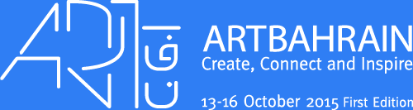

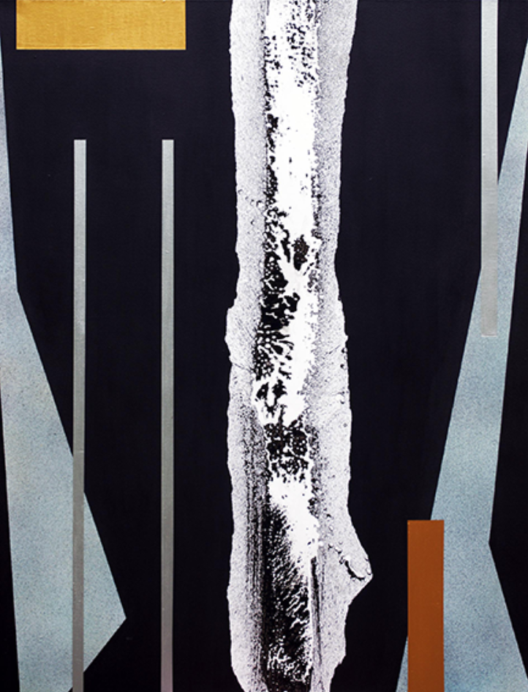
Chasm 1

Patrick Altes is pleased to announce that

Janet Rady Fine Art will be representing his work at
ArtBahrain 2015 (stand 24)

Click Here for a selection of the work exhibited

www.art-bahrain.com
www.janetradyfineart.com

